Montessori Senior Secondary School
A-Camp, Kurnool
Montessori Smart Learning Resource Management System (MSLRMS)
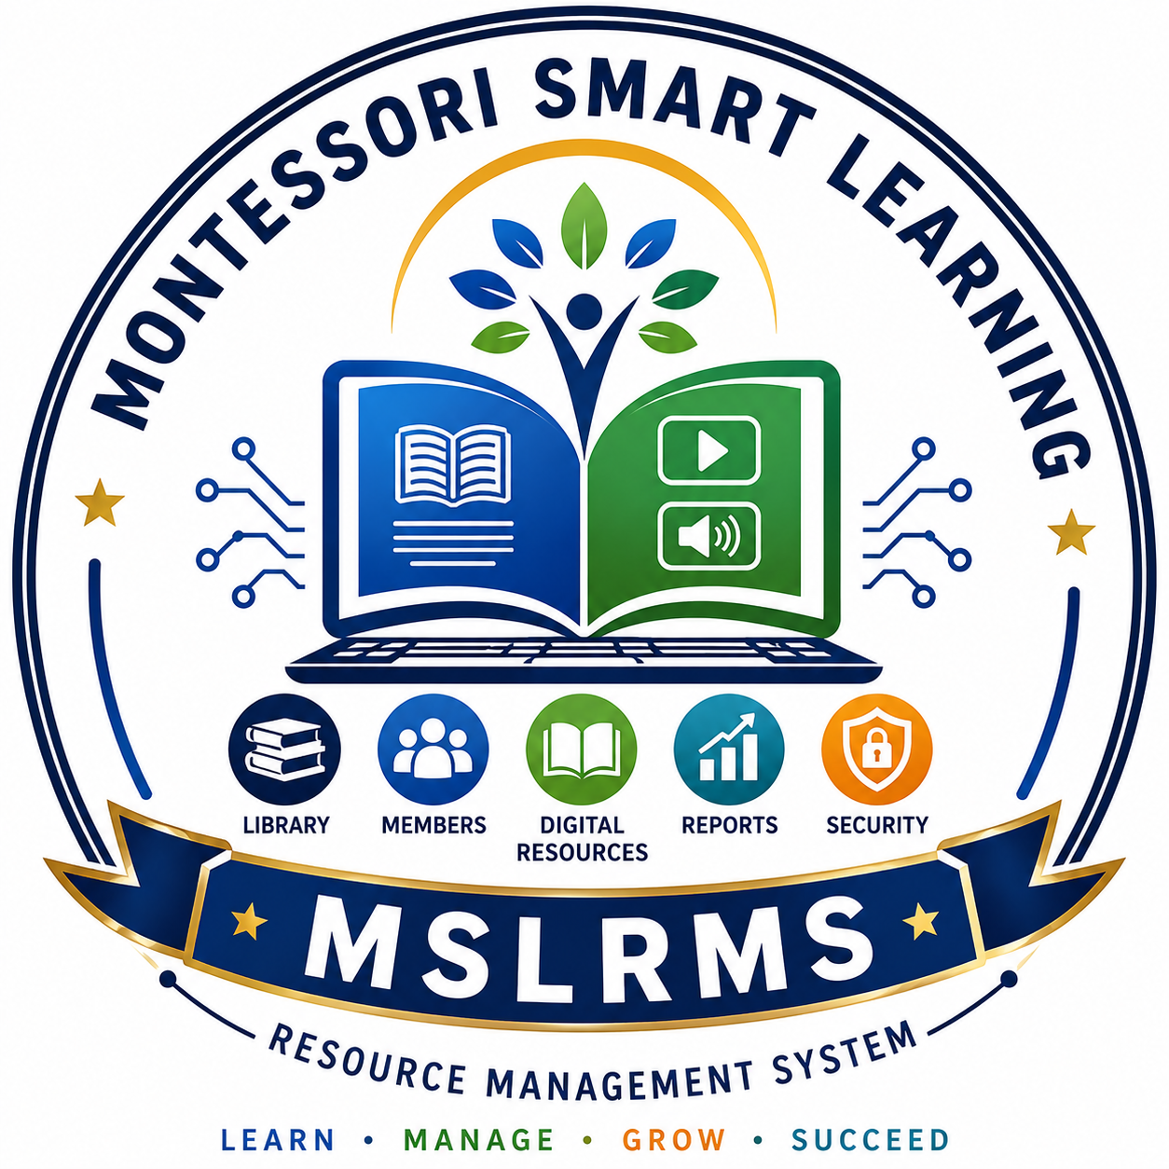
Smart Learning • Smart Library • Smart Future

Software Documentation

Developed By
K. S. Nanda Kishore
Computer Science Department
(Place your School Logo on the left and MSLRMS Logo on the right.)

Version 1.0
Client–Server Based Learning Resource Management Software
2026

PAGE 2 – PROJECT OVERVIEW
About the Project
The Montessori Smart Learning Resource Management System (MSLRMS) is an integrated Learning Resource Management Software developed to automate and modernize library operations while providing seamless access to both physical and digital learning resources.
The application operates efficiently in Online and Offline modes using Client–Server Technology, enabling multiple users to securely access the centralized database simultaneously. It provides a unified platform for managing books, digital resources, students, circulation, reports, and administrative activities, thereby enhancing the overall teaching and learning experience.

Objectives
✔ Digitize library operations
✔ Promote digital learning
✔ Centralize learning resources
✔ Reduce paperwork
✔ Improve resource accessibility
✔ Enable fast searching and retrieval
✔ Support multi-user access through LAN

Technology Stack
Technology | Purpose
Python (Flask) | Backend Development
HTML5 | User Interface
CSS3 | Responsive Design
JavaScript | Interactive Features
SQL Database | Data Storage
Client–Server Architecture | Multi-user Connectivity
LAN / Internet | Online & Offline Access

System Architecture
Administrator
│
┌───────────┴───────────┐
│ │
Librarian Students
│ │
└───────────┬───────────┘
│
Client–Server Network
│
Central SQL Database
│
Physical & Digital Library

PAGE 3 – FEATURES
Core Modules
📚 Library Management
- Book Catalogue
- Book Issue & Return
- Fine Calculation
- Stock Verification
- Lost Book Management

👨‍🎓 Member Management
- Student Registration
- Staff Registration
- Login Authentication
- QR Code Generation
- Role-based Access

💻 Digital Learning Resources
- Digital Library
- PDF Books
- EPUB Books
- DOC/DOCX Files
- PPT/PPTX Presentations
- Audio Resources
- Video Resources
- OCR-enabled Smart Search
- Bookmarks & Favorites
- Reading History

📊 Administration
- Dashboard
- Reports
- Visitor Register
- Donation Register
- Newspaper & Magazine Register
- Certificate Management

Key Features
✔ Online & Offline Support
✔ Client–Server Architecture
✔ Multi-user Access
✔ Centralized Database
✔ Fast Smart Search
✔ QR Code Support
✔ Secure Login System
✔ User-friendly Interface
✔ Responsive Design
✔ Easy Maintenance

PAGE 4 – BENEFITS & FUTURE SCOPE
Benefits
- Improves library efficiency
- Saves time and effort
- Enables paperless management
- Provides secure centralized data
- Supports digital education
- Easy to learn and operate
- Reduces manual errors
- Scalable for future expansion

Future Enhancements
- AI-based Book Recommendation
- Mobile Application
- Barcode & RFID Integration
- Student Analytics Dashboard
- Cloud Backup
- SMS & Email Notifications
- Online Book Reservation
- AI-powered Smart Search
- Teacher Dashboard
- Parent Portal

Conclusion
The Montessori Smart Learning Resource Management System (MSLRMS) is a comprehensive and user-friendly software solution designed to meet the evolving needs of modern educational institutions. By integrating traditional library management with digital learning resources through a robust Client–Server architecture, the system simplifies administration, enhances accessibility, and promotes technology-driven learning. It provides a scalable platform that supports efficient resource management and contributes to the school's vision of delivering quality digital education.

Developed By
K. S. Nanda Kishore
Computer Science Department
Montessori Senior Secondary School, Kurnool

© 2026 Montessori Smart Learning Resource Management System (MSLRMS)

Design Recommendation
To make this document look like a professional software brochure:
- Theme: White background with Royal Blue and Gold accents (matching your school branding).
- Cover Page: School logo (left), MSLRMS logo (right), and a subtle library/network illustration.
- Icons: Use clean icons for Books, Users, Digital Library, Reports, AI, QR Code, and Server.
- Headers & Footers: Include the school name, page numbers, and document version.
- Typography: Calibri or Aptos for body text; bold blue headings with consistent spacing.
- Visuals: Add a simple Client–Server architecture diagram and 3–4 screenshots of your application (Dashboard, Digital Library, Book Issue, Reports) to give it a polished, professional appearance.
This layout is concise, executive-friendly, and suitable for presentations to school management, inspections, exhibitions, and inclusion in your professional portfolio.

